Campus Demonstration: Higher Education

For guidelines on facilitating a tabletop exercise, including developing goals, objectives, rules, after-action reports, and follow-up actions, please see United Educators’ (UE’s) Crisis Response Planning: A Facilitators Guide for Conducting Tabletop Exercises.

Scenario
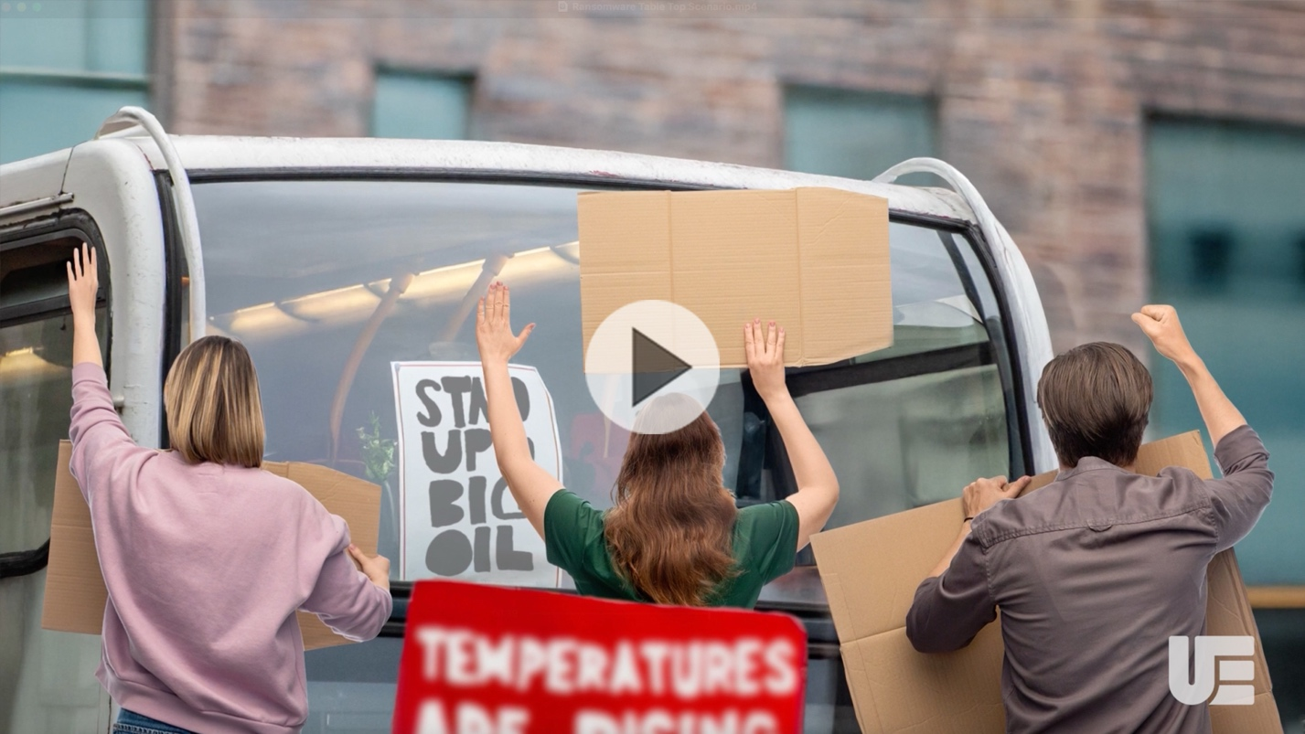
Launch Video (hold the “Control” key down while clicking this link if you’re using Windows)

It’s 9 a.m. Monday, and a large group of demonstrators — including student activists from your college — has gathered in a small park near your campus. The group is rallying to protest your college’s failure to uphold its fiduciary duties by continually investing in fossil fuels. Members claim your school is violating the Uniform Prudent Management of Institutional Funds Act. The rally was well-publicized and, as the morning wears on, busloads of people arrive.

By 1 p.m., when the rally begins, several hundred demonstrators are in the park. There haven’t been reports of violence, but several demonstrators shouted at some of your employees and students for not supporting the cause. While the protest isn’t on your campus, the campus is the focal point for the demonstration.

Discussion questions:
- What are your concerns now?
- What protocols do you have in place for this type of event happening off campus (but nearby)? If you don’t have protocols for this, what actions might you consider taking?
- How and what do you communicate with employees and students on- and off-campus?

Inject 1
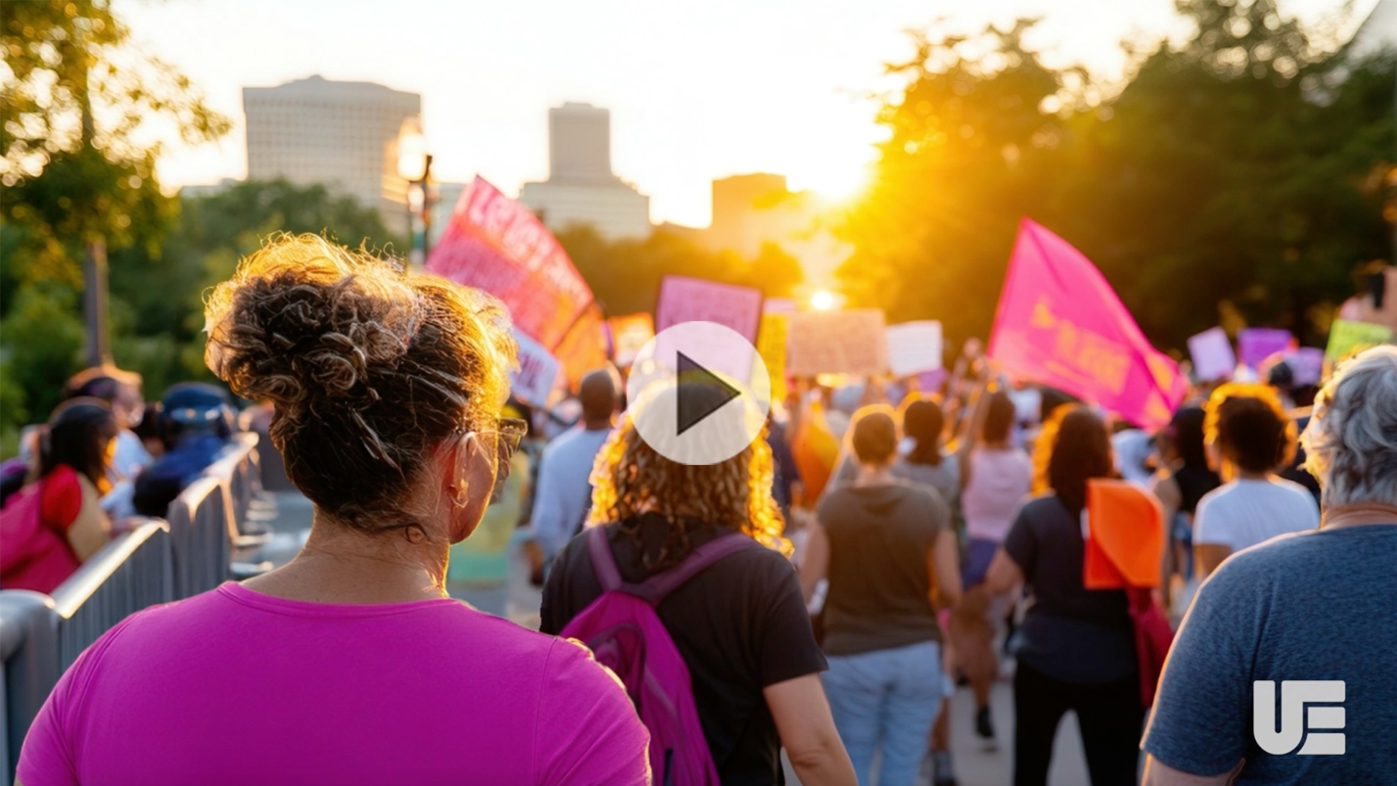
Launch Video (hold the “Control” key down while clicking this link if you’re using Windows)

It’s 4:30 p.m., and the demonstration continues as students and employees begin leaving campus. More demonstrators actively challenge your employees and students to join their cause.

As the protest’s first day ends at 7 p.m., demonstrators begin setting up shelters and tents. The rally takes on a festive atmosphere. Your Public Safety Director reports dozens of students joined the demonstration and made plans to miss class tomorrow to support the cause. Minimal local law enforcement personnel are on scene.

Discussion questions:
- What are your concerns now?
- What are your contingency plans?
- Do you have a specific policy about employees/students participating in demonstrations off campus, but nearby? Does that policy differ for on-campus demonstrations?
- How and what do you communicate with employees, students, parents, visitors, and your campus community?

Inject 2


Launch Video (hold the “Control” key down while clicking this link if you’re using Windows)

At about 11:30 p.m., your Public Safety Director tells you the rally became destructive. Demonstrators overwhelmed the area’s fast-food restaurants, interrupted businesses during the evening hours, and trashed any facility with public restrooms. Your administration building suffered minor damage — a broken window to an office. One of your passenger vans has a shattered windshield. Attempted damage to your utilities was reported, but the utilities remain on. Several clashes with local law enforcement occurred with minimal injuries, but authorities requested more support. You have a similar outlook for the next few days.

Discussion questions:
- What are your concerns now?
- What safety measures can you take for your employees, students, and visitors?
- Are there public relations concerns at this point? If so, does your response adequately address the concerns?
- How and what do you communicate with employees, students, parents, visitors, and your campus community?
- What are your planning priorities now?

Inject 3

Launch Video (hold the “Control” key down while clicking this link if you’re using Windows)

The next morning at about 4 a.m., you check the local news for updates on the rally. Faculty, staff, and students will begin arriving in the next few hours. The crowd has calmed for now, but daylight is coming. More local law enforcement arrived overnight, taking up defensive lines between your campus and the demonstrators. The crowd is larger by several hundred people and has spilled out of the park into the surrounding streets. Dozens of tents are on your campus’ front lawns, and loudspeakers were set up at some point overnight. Indications are that today will be more active than yesterday.

Discussion questions:
- What are your security concerns now? Do you have any other concerns?
- Based on the information you have now, what are your next steps?
- How and what do you communicate with employees, students, parents, visitors, and your campus community?
- How will you work with the local law enforcement throughout the remainder of the incident?
- With which other agencies will you work?
- Do you have any necessary memorandums of understanding (MOU) in place?

Inject 4
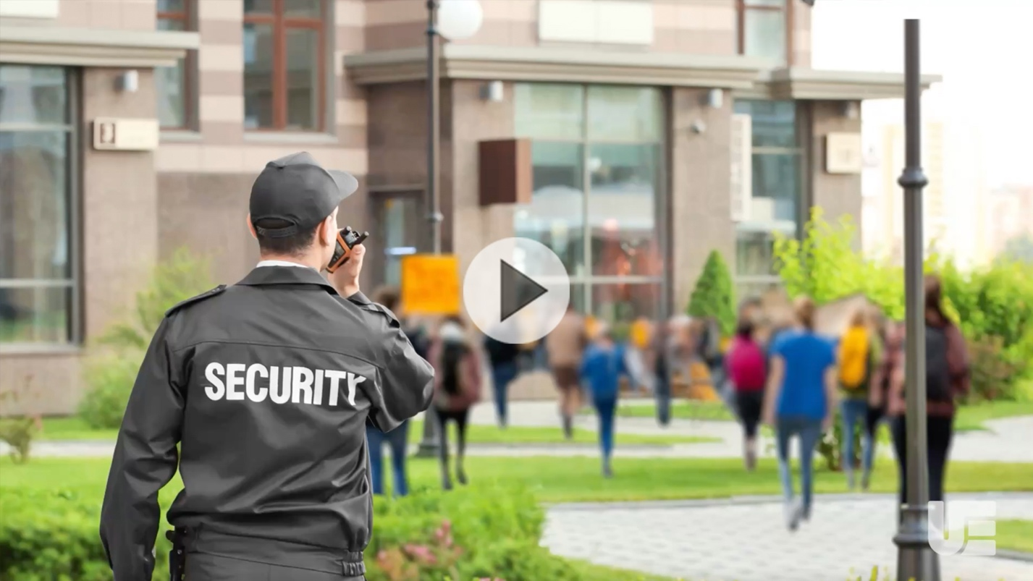
Launch Video (hold the “Control” key down while clicking this link if you’re using Windows)

At about 8 a.m., employees and students are arriving. They successfully navigate their way on campus with support from local law enforcement and your public safety and security staff. As the day progresses, demonstrators’ speeches become more radical and aggressive. They try enticing your employees and students to join their cause by not returning to work and class after lunch. They block the entrance to other buildings and businesses in your vicinity and are harassing people, including employees and students.

By noon, the crowd has overwhelmed all local establishments. The crowd is more aggressive, and there have been minor clashes with local law enforcement.

You learn a faculty member told local news today that he is fed up with your college not divesting from fossil fuels despite fossil fuels conflicting with your school’s mission of improving the world today and for future generations. He says your college had enough time to invest prudently, and since oil and gas investments violate your college’s duty to invest with loyalty and since fossil fuels threaten the lives and prospects of young people and pose a physical threat to school property, it’s no surprise that students and employees have resorted to violence given the board ignored their pleas.

Discussion questions:
- What are your security concerns now? Do you have any other concerns?
- Are there concerns with the comments made by the faculty member to the media?
- How and what do you communicate with employees, students, parents, visitors, and your campus community?
- Based on the information you have now, what are your next steps?

Inject 5

Launch Video (hold the “Control” key down while clicking this link if you’re using Windows)

At about 4 p.m., your students and employees are preparing to leave campus for the day. The rally has deteriorated, becoming aggressive and violent. Local law enforcement is preparing to engage the crowd after police receive word from the Mayor. Unless rally organizers regain control of the crowd, law enforcement will disburse them by using a riot team, tear gas, and rubber bullets. Your parking garage is in the safe zone for now but may not be soon. Demonstrators and tents are blocking the northern entrance of your campus, making it inaccessible.

Your Dean of Students sends you a trending TikTok video where several students are inspired by the faculty member’s comments during today’s interview. Other videos that surface indicate many students are angry at the faculty member for condoning violence. The videos have fueled anger across campus and social media, with many taking opposing sides of the argument. Some side with the faculty member and are upset that your university is doing nothing to help protect the environment and divest from fossil fuels. Others are angry that the faculty member mentions violence as an acceptable means to express that view. This is causing outrage across campus. The hashtag #OurUniversityDoesn’tCareAboutOurFuture is trending.

A new video promotes a separate student demonstration at 8 a.m. tomorrow on the other side of campus.

Tomorrow’s outlook isn’t good.

Discussion questions:
- What are your concerns now?
- What will you share with the media regarding:
- Your plans for deadline with the demonstrations?
- Your faculty member’s comments?
- Do you have criteria for responding to social media posts? If yes, under what circumstances?
- How and what do you communicate with employees, students, parents, visitors, and your campus community?

Review the following UE resources for guidance on managing on-campus demonstrations:
- Addressing Demonstrations on Campus
- Prepare for Violent Protests on Campus

